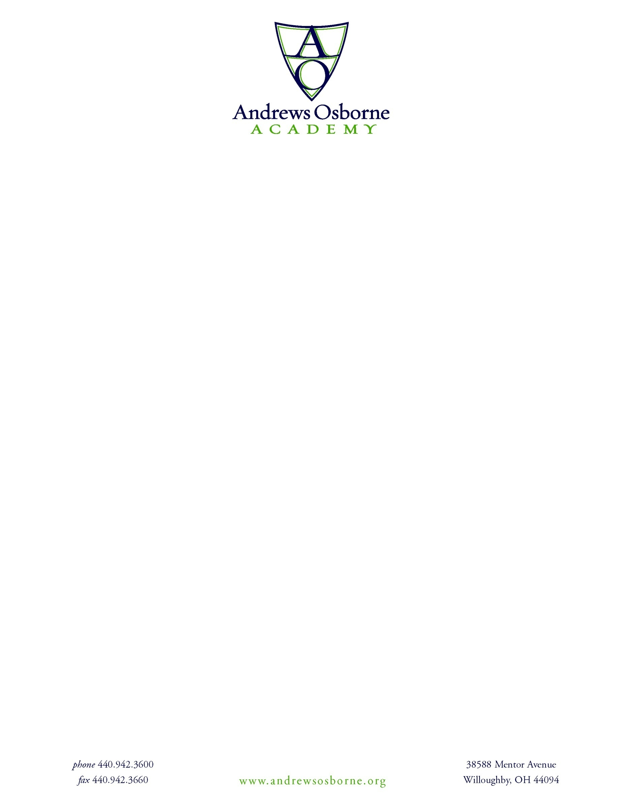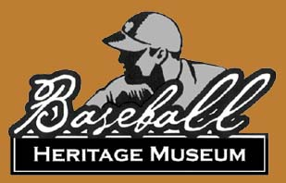

Date: __________________

**BHM BUCKEYES BASEBALL CLUB/AOA TRYOUT LIABILITY WAIVER**

The undersigned voluntarily agrees to participate in the BMH Buckeyes Baseball Tryout held on ______________________________ at Andrews Osborne Academy.

The undersigned recognizes that the Baseball Heritage Museum and Andrews Osborne Academy has not undertaken any duty or responsibility for his or her safety and the undersigned agrees to assume the full responsibility for all risk of bodily injury, death, disability, and property damage as a result of participating in the BHM Buckeyes Baseball Club Tryout.

By my signature, I hereby state that I understand the risks involved in participating in the BHM Buckeyes Baseball Tryout and willingly and voluntarily accept these risks. By my signature, I hereby surrender any right to seek reimbursement from Baseball Heritage Museum and/or Andrews Osborne Academy and its directors, officers, employees, volunteers and other agents for injury sustained and liability incurred during my participation in the activity described above. By my signature, I warrant that I am not relying on any oral representations, statements or inducement apart from the statements made on this form.

By signing below, the parties confirm that they have read, understand, and consent to the terms of this Waiver Agreement.

__________________________________

Printed Participant’s Name

_______________________________________ _________________________________

Parent Signature Printed Name

_______________________________________ _________________________________

Date Phone